Work Motivations

Order the following from 1 - 11 based on how important they are to you in a job.

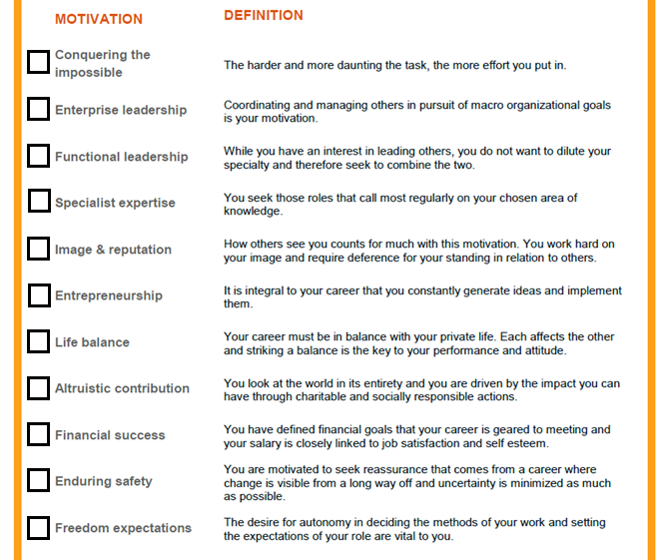

What were your top 3 motivations?

_____________________________________________________________________________

Consider which top rated motivations are not currently being met in your job, and plan your career path to meet these needs.

|  |  |  |  |  |  |  |  |  |  |
| --- | --- | --- | --- | --- | --- | --- | --- | --- | --- |
| **Career Advancement Model** | | | | | | | | |  |
|  |  |  |  |  |  |  |  | Dream  Job |  |
|  |  |  |  |  |  |  |  |  |
|  |  |  |  |  |  |  |  |  |
|  |  |  |  |  |  | Then What? | Then What? |  |  |
|  |  |  |  |  |  |  |  |
| Level of Promotion (i.e. Band Level) | | |  |  |  |  |  |
|  |  |  | Then What? | Then What? |  |  |
|  |  |  |  |  |  |  |  |
|  |  |  |  |  |  |  |  |
|  |  |  |  |  | Next Position |  |  |  |  |
|  |  |  |  |  |  |  |  |  |
|  |  |  |  |  |  |  |  |  |
|  |  |  |  |  |  |  |  |  |  |
|  |  |  | Current Position |  |  |  |  |  |  |
|  |  |  |  |  |  |  |  |  |
|  |  |  | Skills & Expertise (e.g. Job Characteristics, Professions) | | | | |  |
|  |  |  |  |  |
|  |  |  |  |  |  |  |  |  |  |

|  |  |  |  |  |  |  |  |  |  |
| --- | --- | --- | --- | --- | --- | --- | --- | --- | --- |
| **My Career Advancement Model: Path 1** | | | | | | | | |  |
|  |  |  |  |  |  |  |  |  |  |
|  |  |  |  |  |  |  |  |  |
|  |  |  |  |  |  |  |  |  |
|  |  |  |  |  |  |  |  |  |  |
|  |  |  |  |  |  |  |
| Level of Promotion (i.e. Band Level) | | |  |  |  |  |
|  |  |  |  |  |  |  |
|  |  |  |  |  |  |
|  |  |  |  |  |  |
|  |  |  |  |  |  |  |  |  |  |
|  |  |  |  |  |  |  |
|  |  |  |  |  |  |  |
|  |  |  |  |  |  |  |  |  |  |
|  |  |  |  |  |  |  |  |  |  |
|  |  |  |  |  |  |  |  |  |
|  |  |  | Skills & Expertise (e.g. Job Characteristics, Professions) | | | | |  |
|  |  |  |  |  |
|  |  |  |  |  |  |  |  |  |  |

|  |  |  |  |  |  |  |  |  |  |
| --- | --- | --- | --- | --- | --- | --- | --- | --- | --- |
| **My Career Advancement Model: Path 2** | | | | | | | | |  |
|  |  |  |  |  |  |  |  |  |  |
|  |  |  |  |  |  |  |  |  |
|  |  |  |  |  |  |  |  |  |
|  |  |  |  |  |  |  |  |  |  |
|  |  |  |  |  |  |  |
| Level of Promotion (i.e. Band Level) | | |  |  |  |  |
|  |  |  |  |  |  |  |
|  |  |  |  |  |  |
|  |  |  |  |  |  |
|  |  |  |  |  |  |  |  |  |  |
|  |  |  |  |  |  |  |
|  |  |  |  |  |  |  |
|  |  |  |  |  |  |  |  |  |  |
|  |  |  |  |  |  |  |  |  |  |
|  |  |  |  |  |  |  |  |  |
|  |  |  | Skills & Expertise (e.g. Job Characteristics, Professions) | | | | |  |
|  |  |  |  |  |
|  |  |  |  |  |  |  |  |  |  |

Talent Matrix

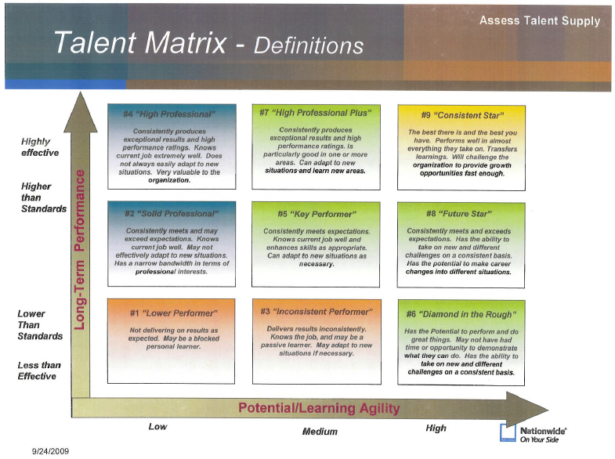

Where do I rank myself?

________

Where do I want to be?

________

How do I plan to get there?

Career Development Plan

Life mission statement (picture collage):

Career mission statement:

|  |  |  |
| --- | --- | --- |
| Type | Action | Date Completed |
| Certifications |  |  |
| Books |  |  |
| Conferences |  |  |
| Mentoring |  |  |